GEOMETRIC UNDERSTANDING OF QUATERNIONS

Table of Contents
1. Preamble 1
2. Complex Numbers 3
Geometry of Complex Numbers 4
3. A Brief History of the Discovery of Quaternions 8
4. Quaternion Algebra 10
5. Some Basic Operations 11
6. Quaternions and Rotations 13
Different Forms of Representation for Complex Numbers and Quaternions 14
Special Coordinate Systems 15
Choice of Special Coordinate Systems 17
Mutual multiplication effect 19
Rotation of a Vector Around an Axis 20
Unit Quaternion Formula 22
7. Practical Example 23
8. What's Next 23
Literature 24

1. Preamble

Typically, the geometric interpretation of quaternion multiplication remains underdeveloped in literature, which is regrettable because the visual properties of the subject help understand its essence and develop the intuition for working with it. Therefore, in this article, I demonstrate how such multiplication is related to geometric objects, primarily in three-dimensional space.

Initially, Hamilton sought and found a system of numbers suitable for rotations in three-dimensional space, but its geometric meaning often eludes us: attempts to visualize quaternions are cumbersome, and the geometric sense of their multiplication is even more obscure. Quaternion multiplication corresponds to two successive rotations around different axes emanating from the origin, and this corresponds to a rotation around a certain resultant axis by a certain new angle. It would be nice to be able to perform such calculations without a pen or computer, exclusively with the help of spatial imagination. Unfortunately, it is not that simple to find explanations on how to do this. Therefore, I will partially fill this gap by explaining how to understand quaternions geometrically and represent them, and to some extent perform their multiplication using simple visual elements — cylinders, planes, and arcs on a sphere. Partly because I will only thoroughly explain how to obtain the resultant axis, not the angle. However, explanations regarding the axis of rotation will be in the video (see link below), while the article itself will lay the foundation for its understanding.

Quaternions can be discussed from various perspectives, and I find this topic to be particularly fertile as a starting point for delving into different directions — group theory, projective geometry, topology. However, these aspects will remain behind the scenes. Here, I will focus more on an introduction to the subject, while more detailed explanations in 3D and all the necessary visualizations can be accessed through the video… and the program available at https://vivkvv.github.io/QuaternionsGeometry/ on GitHub. The source code is also available there: https://github.com/vivkvv/QuaternionsGeometry..

I will take what seems to be the simplest technical path — starting from the algebra discovered by Hamilton and moving to geometric figures known to the ancient Greeks. I suspect it might be possible to do the opposite, but that path has not yet been taken. As a result, we will have a tool for working with algebraic objects, based on spatial imagination, which, in turn, can be refined through algebraic calculations.

The immediate reason for the relative fame of quaternions is their use in computer games and their simpler technique for rotations compared to the rather cumbersome matrix calculations through Euler angles, (although, as I have already noted, many developers do not use them due to the unclear geometric meaning)
Here is a demonstration of rotation in three-dimensional space around a certain axis from Wikipedia:
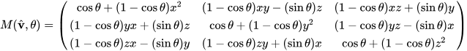

Here, the axis of rotation is defined by the unit vector v = (x, y, z), and the angle of rotation around this vector is θ. Certainly, the elements of this matrix have a certain symmetry, but it still takes effort to derive it from Euler rotations, especially if it's not something you do every day. With quaternions, however, such a rotation can be accomplished more simply, despite the certain cumbersomeness of the expressions. I will talk about this later.
The use of quaternions allows for the generation of similar matrices with less effort. However, when reading descriptions, it often seems that the authors are not fully explaining something, as the connection between their algebra and geometry does not appear transparent. Certainly, there are more coherent explanations available. See, for example, [1]. But the abundance of calculations does not help to clarify the essence. The path followed by the authors of guides is often quite formal, but at the same time, it does not rely on intuition in cases where it could be applicable. As a result, the transparency of the outcome is lost behind the calculations.

2. Complex Numbers
I tried not to discuss complex numbers and to limit myself to a reference to Wikipedia or elsewhere, but for many readers of the preliminary version, this part became an insurmountable obstacle, so I must explain it here. Of course, there is plenty of literature, including quite simple ones, for an introduction to this topic. However, in the context of quaternions, complex numbers allow many things to be explained quickly, correctly, and rigorously, so attention must be given to them. I will not provide a detailed historical overview but will outline only the necessary minimum, in a way that avoids unnecessary questions and misunderstandings. If you already know about complex numbers, feel free to skip this section.
Let's start with a motivational question: why are they needed? Do we really not have enough real numbers, and why invent something else when everything is already good as it is?

Look, let's say we only have natural numbers: 0, 1, 2, 3, ... (including zero in this list is a matter of convenience, although some believe that this is the main contribution of French mathematics to science). Some people believe that these numbers are given from above, and all the rest is the work of human hands/minds. This view leads to incorrect conclusions, and its source lies in the belief in the divine origin of the natural series. Of course, in nature itself there are not only no integers, but no numbers at all (and if there are, we cannot know about them). Therefore, although it may seem strange or surprising to some, both physics and mathematics can be considered social sciences in a certain sense.

So, we can add natural numbers, and as a result, we get natural numbers again. But for the opposite operation, subtraction, natural numbers are not enough. To make subtraction usable, we need to extend the concept of natural numbers and introduce negative numbers, which together with the natural numbers make up the integers: 0, -1, +1, -2, +2, -3, +3, ... That is, we just took and added an infinite number of new objects that were not even mentioned before. Who told us that these new digits with a "minus" sign in front of them are also numbers? No one! We told ourselves. In their pure form, they also do not occur in nature. Compared to natural numbers, they are no less and no more real.

So, integers can be added and subtracted (the latter being the inverse operation to addition). These two arithmetic operations will not take us out of the realm of integers. The same is true for the operation of multiplication, but for division, the inverse operation to multiplication, suitable numbers among integers are not found. To make division usable at all, we need to expand our numbers to include rational numbers, i.e., objects of the form m/n, where m and n are integers. It is important to note that initially, we did not know what rational numbers were, we added them to integers for convenience. In rational numbers, we can solve any linear equation with rational coefficients a and b:
a · x + b = 0 (2.1)
as
x = -b / a (2.2)
Thus, we add to the integers numbers of this kind, obtaining rational numbers.

Now I will jump straight to real numbers. Let's assume they already exist for us from somewhere. Do we need to expand the concept of a real number in any way if we want to solve (2.1) with real coefficients a and b? No, we don't, the solution will have the same form as (2.2). But what can be said about quadratic equations?

a · x² + b · x + c = 0 (2.3)

I don't want to tire you with general formulas; it's clear that some solution can be obtained. But let's look at something simpler and more specific:
x² = -1 (2.4)

It's clear that there are no real numbers that solve (2.4). Therefore, let's do as before: we will append to the real numbers another one, which we will denote as i, such that
i⋅i=−1 (2.5)
(It's obvious that -i also satisfies (2.5)). Now let's compose all possible combinations of this new number with the existing real numbers. We will call such objects complex numbers with the general form
z = a⋅i + b (2.6)

here a and b are the old real numbers. Of course, a and b can also be the newly introduced complex numbers, but after simplifications due to (2.5), the result will take the form of (2.6).

Thus, we arrived at complex numbers from integers, gradually complicating the equations and the objects involved in them. These equations and objects emerged in people's practical activities, and it took complex numbers time to emerge from prehistoric times to, conditionally, the year 1530. Although, I suspect that even the people of ancient Egypt were already prepared for them.

Geometry of Complex Numbers

The fuller history of the discovery of complex numbers is quite fascinating and connected to many aspects of mathematics, but we won't delve into it in detail. Instead, we will focus primarily on their geometric interpretation, so I will introduce them in a geometric way.

So, imagine a plane with points on it. Let's define a Cartesian coordinate system on this plane, where each point is specified by a pair of its coordinates (x, y). It's clear that the origin and the direction of the axes can be introduced in a rather arbitrary manner, but for our further purposes, it will be sufficient to use those among them whose axes are perpendicular to each other, and the origin is always in the same point (traditionally denoted as O). Now, let's ask the following question: how can we transform one point A1 with coordinates, say, (x1, y1) into another point A2 with coordinates (x2, y2)?

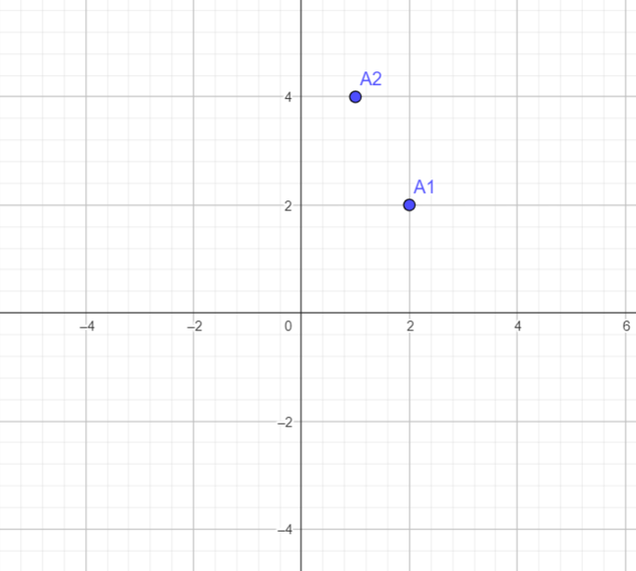

If points A1 and A2 are at the same distance from the origin, then this can be achieved through a certain rotation around the origin. If these two points lie on the same ray emanating from the origin, then you need to multiply the coordinates of one of the points by some number to obtain the coordinates of the other point. From here, it's clear that one point can be transformed into another by performing two operations: rotation and scaling.

This leads us to the concept of "multiplication" of points on a plane. Such a point can be written, for example, as (x, y), or as (r, φ), where r is the distance from the origin, and φ is the angle of rotation of the point relative to the X-axis, with the axis of rotation passing perpendicularly through the point O on the plane, and the direction of positive angles (again, traditionally) being counterclockwise. We have not yet introduced the concept of multiplying points, but let's do it, starting from the "multiplication" of points on the axes, which can correspond to real numbers. Real numbers in this approach could be represented by points on the X-axis and have the form (x, 0) (since the projection of the points of the X-axis onto the Y-axis is zero). The multiplication of two real numbers in such notation equals (x1, 0) * (x2, 0) = (x1 * x2, 0), i.e., the distances from the origin are multiplied: (r1, 0) * (r2, 0) = (r1 * r2, 0). From this, after some reflection, it becomes apparent that the notation (r, φ) is better suited for our purposes. And what happens in the case of two now arbitrary points, and not only those lying on the X-axis?

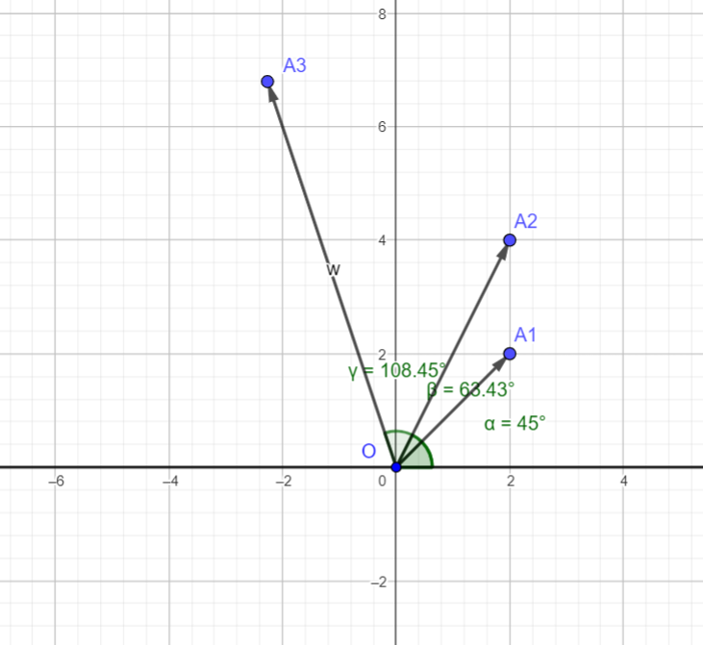

Let's agree that the result of "multiplying" two points (r1, φ1) and (r2, φ2) on the plane will correspond to the point (r1 * r2, φ1 + φ2). I cannot say here: "that's how it is," because this was our attempt, we initially do not know whether it will lead us to any problems or contradictions, but it is not difficult to see that no particular problems are anticipated.

So, in summary, we have a plane with an origin and what's known as a polar coordinate system, in which the coordinates of points are defined by the distance from the origin and the angle of rotation. And let's define the operation, which we call multiplication, by associating any pair of points with a third point according to the formula:
(r1, φ₁) ∗ (r2, φ₂) = (r1∗r2, φ₁ + φ₂) (2.7)

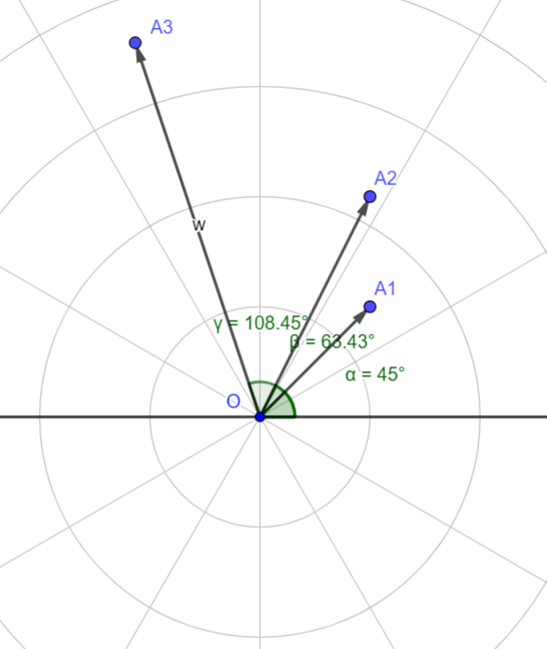

Then, each pair (r, φ) will be called a complex number. Moreover, if the rotation angle φ is zero, then the formula becomes (r1, 0) * (r2, 0) = (r1 * r2, 0), which means that for a zero angle, the formula represents the multiplication of real numbers.

But now a fundamentally technical question arises. The pair (r, φ) (or the complex number corresponding to this point) belongs to a two-dimensional plane. Can this point be represented as some kind of decomposition along axes? The answer here is quite obvious, as r and φ are related to x and y by simple relationships.
x = r * cos φ (2.8)
y = r * sin φ (2.9)
From where
r = (2.10)
φ = arctg(y / x) (2.11)

I suggest verifying that complex numbers, formed in the image of (2.6) from x and y as:

z = x + i y = r * cos φ + i * r * sin φ (2.12)

When multiplied, they will behave in accordance with (2.7).

Let's introduce a few more concepts related to complex numbers. For a complex number z, the so-called conjugate plays a special role:

z = x + iy (2.13)
= x – iy (2.14)

because their product equals the sum of the squares of the components, or simply the square of the length:

z = z = |x|² + |y|² = |z|² (2.15)

It's also necessary to mention another formula, without which life would seem more difficult — this is Euler's formula:

(2.13)

Then, (2.12) will take the form:

z = r (2.14)

Here is not the place to delve into why trigonometric functions are suddenly related to the exponential in such a way. If this is completely unclear, then consider (2.13) simply as a shorthand way of writing such a sum of sine and cosine. It's important to note that trigonometric calculations using (2.13) can be performed faster, and this does not affect the results.

For those who have never encountered such reasoning before, and for whom such correspondences between algebraic objects with seemingly arbitrarily introduced operations and geometric objects on the plane seem miraculous and incomprehensible, I want to encourage you. The understanding of complex numbers did not emerge immediately, even when everything was already in place for it, and it broke through slowly (by the way, Hamilton also made his mark here). And even at the finish line, it took about two hundred years. Therefore, if an individual can grasp this connection more quickly, that's already good. To get comfortable with these concepts, it's worth practicing a bit with the addition, multiplication, and division of complex numbers, and you will feel as comfortable with them as a fish in water..

3. A Brief History of the Discovery of Quaternions

The concept of quaternions was developed by the eminent Irish mathematician and physicist William Hamilton. Notably, their discovery was not a result of random calculations; Hamilton specifically sought to find them. He was in search of algebraic entities that resembled complex numbers (since it was Hamilton who had conclusively characterized complex numbers as pairs of real numbers) but, unlike them, would describe operations not in a two-dimensional plane but in three-dimensional space.
Actually, this story turned out to be quite fascinating. I will recount it very briefly here, but you will enjoy learning more about it. The most detailed description in Russian I found in the book [2] (see also [3]).
Honestly, I sometimes feel like a speck of dust compared to people like Hamilton. Take quaternions, for example. I've spent a tremendous amount of time (not two hundred years, but still, it's been decades) just to superficially understand them, while he not only comprehended but actually discovered them. And he didn't just discover them; he did it, so to speak, on demand.
But when you start digging into the details, the situation gradually improves. For instance, initially, Hamilton (and not just him, others like Wessel, Argand, Bellavitis, and even Gauss were moving in this direction before him, which is somewhat reassuring since even Hamilton didn’t start from scratch) was, by analogy with complex numbers, looking for a way to multiply "triplets": (x1+iy1+jz1) * (x2+iy2+jz2). These triplets were supposed to represent either points in three-dimensional space or, somehow, be responsible for rotations. Here, i and j are different imaginary units, for which i²=j²=-1. The main obstacle was figuring out the product of i*j.
So how would we approach this today? Well, let's decompose this product into a linear combination of imaginary and real units: i * j = A*1 + B*i + C*j. Let's multiply this expression on the left by i (oh yes, there's also the issue of commutativity here, as nobody assumed that the factors might not be commutative, but let's ignore that for now). Since the square of the imaginary unit is minus one, we get -j = A*i - B + C*i*j = A*i - B + C * (A + B*i + C*j) = A*i - B + C*A + C*B*i + C²*j. Or 0 = (CA - B) + (A + CB) i + (C² + 1) j. Zero equality means that all components of these three terms must be zero, i.e., all coefficients at the units - imaginary and real. But how is this possible for C² + 1? Something doesn't add up. Moreover, the concept of linear independence as we understand it today did not exist at that time, so it wasn't straightforward to even come to such a conclusion (I'm not sure if I'm mistaken here, at that time the concept of linear independence already existed, but that was for linear spaces, not algebra. In any case, there were few pioneers in this area, so Hamilton was forced to wander in relative darkness anyway. In short, if you have something to say on this matter — write in the comments.)
But Hamilton thought hard. And in 1843, after 13 years of intense thinking, it finally dawned on him that if two parameters were needed for operations on a plane - a rotation angle and a stretching factor, which could transform any point into any other (characteristic for complex numbers), then the situation in three-dimensional space was different. One needed to specify the axis of rotation (two parameters - latitude and longitude, which are two angles), the angle of rotation (another parameter), and the stretching factor. That's four in total. But in the expression A + Bi + Cj, there are only three. One parameter is missing. Therefore, it was necessary to add another term: A + Bi + Cj + Dk, where k is another imaginary unit, whose square is also -1. Thirteen years for such a discovery seems a bit too long. Self-esteem continues to grow. Interestingly, this news simply astonished Hamilton's friends, who were aware of his creative pursuits. So, he was not the only one who was a simpleton.

After that, things started moving. Hamilton compiled a multiplication table for quaternions, learned to describe rotations in three-dimensional space using them, and wrote so much about them (including a 700-page treatise that was generally considered unreadable) that other physicists and mathematicians had to grapple with them for another seventy years. In the process, vector calculus and modern terminology (vectors, scalars, tensors, divergence, and much more) were created, although all this was accompanied by fierce discussions and quarreling, and scientists split into irreconcilable camps, and the temperature only dropped several decades later. The storm, by the way, continued long after Hamilton's death in 1865. As they say, the circus left, but the clowns remained. They chose leaders inspired by quaternions, who elevated Hamilton's creation to divine heights, faithfully believing in the new idols. In this tumultuous movement, besides Hamilton himself, Tait, Maxwell, Heaviside, Klein, Nott, Gibbs, Hertz, Peano, and other famous people distinguished themselves. That's almost all from me, and those who are interested can read Polak's [2] chapter on quaternions.

Nevertheless, it should be added that among Hamilton's texts, it is likely one can find everything I am going to talk about here, both about the algebra of quaternions and their geometry. I am in no way claiming priority, especially in contradiction to Hamilton.

4. Quaternion Algebra

Knowing that there is one real unit and three imaginary ones, we can proceed to the multiplication table of quaternions. I think it didn't take Hamilton very long to compile it. Judge for yourself. Suppose we have four elements (a set of units). What can result from multiplying each of their pairs? The simplest variant to check would be some unit not included in this pair, possibly with a minus sign. In general, it doesn't take long to check. And the result is as follows:

ij=−ji=k, jk=−kj=i, ki=−ik=j (4.1)

Perhaps, the equation (4.1) is not so obvious. But let's check. Let's agree to assume that:

i²=j²=k²=−1 (4.1.1)
and let's try to convince ourselves that the following product:

i⋅j=k (4.1.2)

can be considered a good candidate, leading to a consistent multiplication table. Let's multiply (4.1.2) on the right by j:

i⋅j⋅j=k⋅j
Then, considering (4.1.1), we have:

−i=k⋅j (4.1.3)
Now, let's multiply (4.1.2) on the right by k:

i⋅j⋅k=k⋅k=−1 (4.1.4)

Now, let's multiply (4.1.4) on the left by i:

i⋅i⋅j⋅k=−j⋅k=−i (4.1.5)

Comparing (4.1.3) and (4.1.5) we see that:

k⋅j=−j⋅k (4.1.6)

Therefore, the expressions in (4.1) can be partially derived from conditions (4.1.1) and (4.1.2). In fact, it's not at all obvious that anything should have worked at all (as already mentioned above, such an approach doesn't work in the three-dimensional case at all). Thus, of course, in the four-dimensional case it was bound to work, but Hamilton initially didn't know this for certain. It turned out (and this can be proven) that such types of algebras exist only in cases of several dimensions, namely - 1 (real numbers), 2 (complex numbers), 4 (quaternions), and 8 (octonions). But of course, we will focus only on quaternions. Moreover, the fact that

i⋅j=k

does not negate the fact that other linear combinations of the basis elements (i.e., our four units) can also yield correct multiplication tables. For example, combinations like:

i′=0.549697⋅i−0.0336984⋅j+0.834673⋅k (4.1.7)
j′=0.593344⋅i+0.719079⋅j−0.361731⋅k (4.1.8)
k′=−0.588012⋅i+0.694097⋅j+0.415274⋅k (4.1.9)

also lead to equations similar to (4.1), i.e.,

i′⋅j′=k′ (4.1.10)

Later, we will return to these types of transformations and see their geometric meaning. By the way, here I used what is known as the associativity of quaternion multiplication, i.e., the independence of the result from the order of performing multiplication operations:

a(bc) = (ab)c = abc (4.1.11)

Quaternions are indeed associative, let it be an exercise to prove this.

5. Some Basic Operations

In the future, we will have to perform various operations with quaternions, but all of them will consist of something simple, which we will cover in this section. For now, all expressions will be algebraic, but soon we will see their geometric interpretation..

It's important to note that the imaginary quaternion units are non-commutative, unlike the real unit, which is commutative with the others. This distinction stands out, and we will encounter it in the geometric interpretation as well. Quaternions will be written in the form:

q = q₀ + iq₁+ jq₂ + kq₃ = q_{o} + (5.1)

We often deal with purely real quaternions (where only the real part of the quaternion is non-zero) and purely imaginary ones (where only the real part is zero). In the latter case, such a quaternion is traditionally called a vector. This name is justified by the three-dimensionality of this part. Then in (5.1), q₀ is the scalar part, and is the vector part of the quaternion.

It's easy to verify through direct calculations that the product of two quaternions u = u₀ + and v = v₀ + is
uv = u₀v₀ − (,) + u₀ + v₀ + [,] (5.2)

Where the round brackets indicate scalar multiplication, and the square brackets vector multiplication in the modern sense. I suggest you do an exercise to check formula (5.2). It's worth noting that if the coefficients at j and k for each of the quaternions are zero, then such a product coincides with the multiplication for complex numbers. The analogy with complex numbers suggests introducing the concept of the conjugate quaternion:

= q₀ − iq₁ − jq₂ - kq₃ (5.3)

It is easy to verify that the result of multiplying a quaternion by its conjugate contains only the real component. This product can logically be called the square of the modulus of the quaternion q, fully consistent with the complex number case:

q = q = |q|²=u₀²+u₁²+u₂²+u₃² = |q|²(5.4)

From this last equation, a method for finding the inverse of the quaternion q can be derived:

= /|q|² (5.5)

As it can be easily verified that:

q = q = 1 (5.6)

In the case of purely imaginary quaternions, (5.2) transforms into:

= -(, ) + [, ] (5.7)

By the way, we will need the conjugation of a vector later on:

(5.8)

It is not difficult to see what the inverse of the product of vectors is:

(5.9)

The conjugate of the product can be obtained from (5.5) and (5.9):

(5.10)

In the case of unit vectors, we will have:

(5.11)

It should also be noted that we will be interested in unit quaternions, i.e., those for which the square of the modulus equals one. However, the addition operation will not be needed at all. Of course, in the notation of the quaternion itself, the sign "plus" is used between the components, but this could easily be avoided by defining the quaternion as an ordered quartet of numbers, i.e., u = (u₀, u₁, u₂, u₃) instead of u = u₀ + u₁i + u₂j + u₃k.

6. Quaternions and Rotations

In this section, we finally begin to connect quaternions with rotations in three-dimensional space, although so far we only have a four-dimensional space and quaternions in it. We will consider its three-dimensional subspace (on the axes corresponding to i, j, k) with its purely imaginary quaternions (i.e., as mentioned, vectors) and identify it with real three-dimensional space. We will focus on unit quaternions, for which the relationship is:

|q|² = q₀² + q₁² + q₂² + q₃² = 1 (6.1)

Hamilton called them versors (https://en.wikipedia.org/wiki/Versor)

We lose little by considering only unit quaternions, as any quaternion can always be expressed as a unit quaternion multiplied by some real number. This multiplication corresponds to a certain scaling. Consequently, the operation of multiplying general quaternions will differ from that of multiplying unit quaternions in a minimal way, but this significantly simplifies our analysis.

From (6.1) it is clear that the three components (q₁, q₂, q₃) determine the fourth (q₀) up to the sign, which we will keep in mind but ignore for the time being. Thus, it turns out that any quaternion can be specified by a triplet of numbers, each of which can take values in the closed interval [-1, +1], i.e., lie inside a unit radius sphere. The fact that rotations can be described by such a sphere is well-known. See, for example, [5], Chapter 1, Section 1, Item 2.

Let's recall once more how we arrived at three-dimensional space. Initially, by analogy with complex numbers, it was necessary to introduce a fourth parameter (the third imaginary unit), which was supposed to enable the transformation of a certain quaternion into any given one through multiplication. Then, by discarding the possibility of scaling, we eliminated the fourth parameter, limiting ourselves to three-dimensional space, although the fourth dimension didn't actually disappear.

This section is dedicated to the use of quaternions for rotation around a certain axis. In many sources that discuss this topic, the necessary result is often obtained very quickly and obscurely, leaving the reader puzzled. While the result is there and can be verified, a mysterious aura remains – how could one possibly have thought of this?

So, let's approach this from a distance. Let's recall complex numbers again, which we wrote in the form:

z = x + iy (6.2)

where x and y are real numbers. A quaternion, using the properties of imaginary units, can be rewritten as:

q = q₀ + iq₁ + jq₂ + kq₃ = (q₀ +iq₁) + j(q2 - iq3) = q_{0,1} + iq_{2,-3} (6.3)

Expression (6.3) is similar to (6.2), but the coefficients are complex instead of real. The transition from real to complex numbers involved doubling real numbers (transitioning from a single real number to a pair) and moving from a line to a plane. The transition to quaternions involves replacing the real coefficients in (6.2) with complex ones (i.e., each axis should be replaced with a complex plane) and moving to a four-dimensional space.

Different Forms of Representation for Complex Numbers and Quaternions

There is a way to rewrite complex numbers in matrix form, and then (6.2) will be written as

z = (6.3)

And it's not difficult to verify that the properties of multiplying complex numbers, when written in this matrix form, correspond to the multiplication written in the standard form (6.2). Therefore, it's easy to understand that quaternions can also be rewritten in the same form, using (6.3), namely:

q = (6.4)

Here, it should be noted that the determinant of this quaternion equals one. There may be some issues with understanding the signs, but everything falls into place if (6.4) is written as follows:

q = , a = q₀ + iq₂, b = q₁ + iq₃ (6.5)

(6.5) can be understood as an object in two-dimensional complex space. And if we also consider (6.3), then (6.5) can be rewritten as an object in four-dimensional real space:

q = (6.6)

Again, the signs may seem unclear, but it is enough to check that the product of two matrices of the form (6.6) leads to a consistent result.

If the analogy between quaternions and complex numbers seems far-fetched to you, or if the method of representing both as matrices is unclear, I recommend the book [6], Part I, Chapter 7, “Visualizing Algebraic Structure”. The book is generally on our topic, and in this section, the author focuses on the possible representations for complex numbers and quaternions.

Special Coordinate Systems

Usually, the explanation of using quaternions for rotations in three-dimensional space is carried out more or less straightforwardly, using only the definition of quaternion multiplication and relatively long algebraic transformations. However, I want to offer a slightly improved method that simplifies this path. The idea is to perform quaternion multiplications in specially selected coordinate systems that facilitate the task. Let's start by writing the quaternion in the form of (6.3):

q = (q₀ +kq₃) + (q₁ + kq₂)i = q₀₃ + q₁₂i

Here, the terms q₀₃ and q₁₂ can be written in trigonometric form, using (2.14):

q₀₃ = q₀ + kq₃ = |q₀₃|
q₁₂ = q₁ + kq₂ = |q₁₂|
i.e.

q = |q₀₃| + |q₁₂|i = |q₀₃| + i|q₁₂| (6.7)

We have divided our quaternion into two parts — those in the planes (0, 3) and (1, 2). Assuming 1, 2, 3 as the axes x, y, z respectively, and 0 as w, we see that the quaternion is decomposed into parts belonging to the planes (w, z) and (x, y). The usual three-dimensional space includes the components x, y, z.

And we will need to multiply this quaternion by another, p:

p = |p₀₃| + |p₁₂|i = |p₀₃| + i|p₁₂| (6.8)

Here, the sign near one of the angles changed due to the change in the position of the multiplier i. Now, during multiplication, we will have to deal not with 4 x 4 = 16 terms, but with 2 x 2 = 4 terms. Is it possible to further simplify these expressions?

Look, we consider our quaternions in a certain arbitrary coordinate system. But is it possible to choose it in such a way that expressions (6.7) and (6.8) become even simpler? Can we perform a certain rotation so that p₁₂ becomes zero? After all, in ordinary three-dimensional space, you can always rotate a vector so that it is oriented along the z-axis. Of course, the quaternion q will also change in this process. And that's not all. After that, we can perform any rotation around the z-axis. In this case, the quaternion p will not change anymore, but it is possible to achieve, for instance, that the x-component of the quaternion q also becomes zero.

We will soon turn our attention to these rotations, but first, we need to ensure that such an approach is feasible and that transitioning to a different coordinate system won't disrupt the properties of quaternion multiplication. It might turn out that such a transition significantly alters the outcome, resulting in the transformed quaternions multiplying according to a different rule. To verify that everything works as expected, let's identify linear transformations of quaternions that preserve their real component while only transforming the vector parts (x, y, z components), yet keeping the scalar part of the quaternion product unchanged. From (5.2) we obtain:

pq = p₀q₀ - (, ) + p₀ + q₀ + [,] (6.9)

Now, when changing the coordinate system, p transforms into p', and q into q', with p₀ = p₀’, q₀= q₀’, since the transformations only affect the vector part. The product of these new quaternions will be:

p’q’ = p₀q₀ - (’, ’) + p₀’ + q₀’ + [’,’] (6.10)

Allowable transformations should not change the scalar part, i.e.,

(, ) = (’, ’) (6.11)

(6.11) requires the independence of the scalar product of vector parts from our transformations, i.e., from the choice of the coordinate system, and this constitutes orthogonal transformations, meaning all permissible rotations.

But what happens to the vector part (6.9) during such rotations? What does transform into

p₀ + q₀ + [,] ? (6.12)

Since p₀ and q₀ remain the same, the first two terms will transform in the same way as any vector in a three-dimensional coordinate system. It's also easy to see that the vector product (the third term) behaves similarly. That is, in the case of orthogonal transformations S (arbitrary rotations of the three-dimensional coordinate system):

p = (p₀, ) → p’ = (p₀, ’) = (p₀, S) (6.13)
q = (q₀, ) → q’ = (q₀, ’) = (q₀, S) (6.14)

The result of quaternion multiplication will transform as:

p₀q₀ - (, ) + p₀ + q₀ + [,] → p₀q₀ - (, ) + S (p₀ + q₀ + [,]) (6.15)

And this means that during such transformations in three-dimensional coordinate systems, the scalar part of the quaternion product remains unchanged, and the vector part is transformed in the same way as a three-dimensional vector. Thus, we can comfortably perform any rotations, carry out the quaternion product in a new coordinate system, and then do the reverse transformation if we want to know what the original, untransformed result looks like. However, we usually won't perform this last operation, because what will be important for us is only the relative positioning of the vectors (both the original and the results), not some absolute values..

I want to emphasize again the importance of the result we've obtained, as it allows us to reason about the quaternion product without being tied to a specific three-dimensional coordinate system. What matters is the relative positioning of the quaternions. For example, we will often move to a coordinate system where the first quaternion is aligned along the z-axis. In this context, the most crucial parameter of the vector part of the second quaternion will be the angle between it and the vector part of the first quaternion.

Choice of Special Coordinate Systems

Now, let's move to a coordinate system where the first quaternion has only z and w components, and the second one has z, w, y components. Here is the scheme for this transformation, assuming we start with arbitrary unit quaternions:

- Perform a rotation around the y-axis so that the x-component of the first quaternion becomes zero.
- Next, perform a rotation around the x-axis so that the y-component of the first quaternion (not the original, but the one obtained after step 1) becomes zero. The x-component, which was already zero, remains unchanged. After this, we get the first quaternion oriented in the direction of the z-axis.
- Now, you can rotate around the z-axis as much as you like; it will not affect the first quaternion anymore, but it allows you to zero out the x-component of the second quaternion.

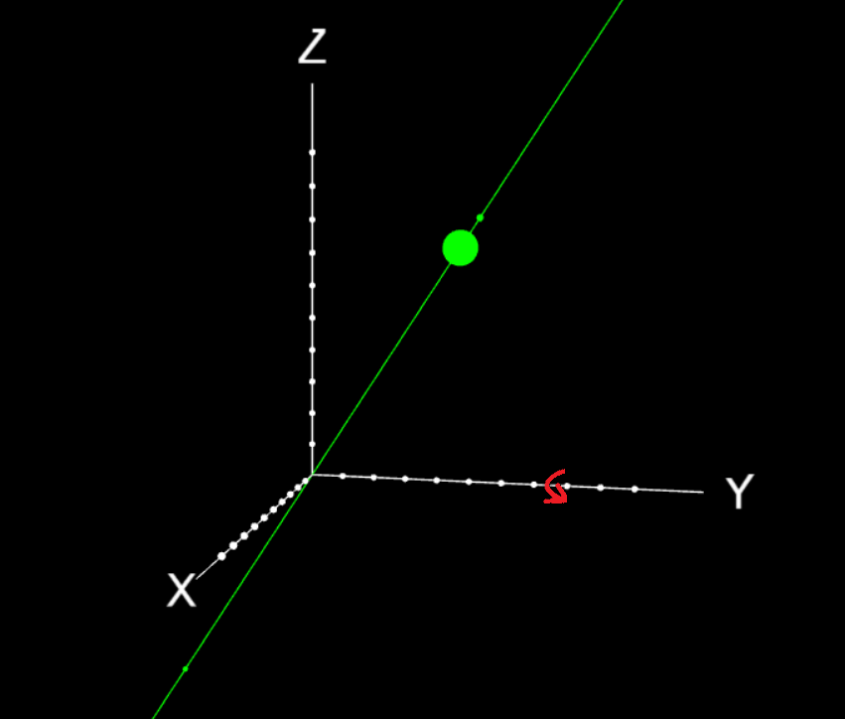
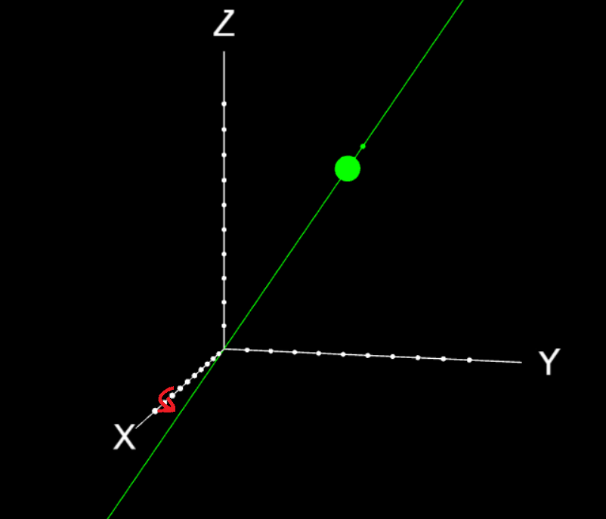
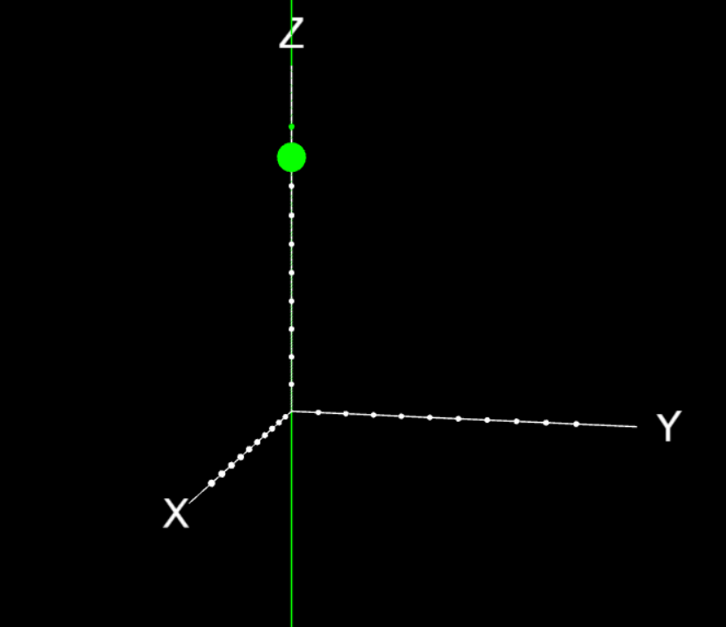
Последовательными поворотами добиваемся ориентации оси кватерниона в направлении z

By performing consecutive rotations, we achieve the orientation of the quaternion's axis in the direction of the z-axis.

q = |q₀₃| = (6.16)
p = |p₀₃| + jp₂ (6.17)

Here I took into account that the quaternions are unitary, so |q₀₃| equals one. Now, multiplying them becomes very simple:

qp = |p₀₃| + jp₂ (6.18)

And now the advantage of using special coordinate systems becomes clear. From (6.18), it's apparent that if we consider the quaternion multiplication qp as the action of q on p, which translates p into some new quaternion, then this action is reduced to the rotation of the original components of p by an angle defined by q, both in the (z, w) plane and the (x, y) plane. In three-dimensional space, this looks like the rotation of the vector part of p by an angle defined by the quaternion q, around an axis defined by the vector part of the quaternion q. This also changes the z-component of the quaternion p. Thus, in three-dimensional space, this looks like the movement of the vector along the surface of a cylinder described around with a radius equal to the distance in three-dimensional space from to .

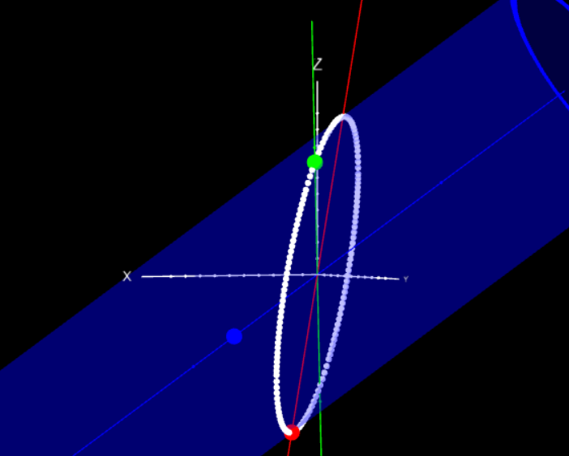
The movement (white track) of the resulting quaternion (red) along the surface of the cylinder as the angle phi changes. See details on https://www.youtube.com/watch?v=m92PeX1wDgI&list=PLdCIDX-rXAfTDQzhWGkgnF0K4zb0ySsBO&index=2&pp=gAQBiAQBsAQB

Mutual multiplication effect

It's interesting to note that the same multiplication can be viewed symmetrically, i.e., not as an action of the quaternion q on the quaternion p from the left, but as an action of the quaternion p on the quaternion q from the right, i.e., not as...

q : p → p’ (q acts on p from the left) (6.19)

but rather as

q’ ← q : p (p acts on q from the right) (6.20)

But to demonstrate this, it's more convenient to switch to a different coordinate system — one in which the second quaternion (p) has components z and w, and the first (q) — z, w, y, that is

q = |q₀₃| = |q₀₃| + jq₂ (6.21)
p = (6.22)

And then

qp = |q₀₃| + jq₂ (6.23)

(Obviously, the angles here have different values than in (6.18))

And now it is interpreted as a change in the quaternion q, and its components have undergone rotation both in the (z, w) plane and in the (x, y) plane at an angle determined by the quaternion p. The only difference is the sign of the angle for the (x, y) plane, because if in the first case the quaternion p rotated in the xy plane (i.e., the plane perpendicular to ) clockwise, now the quaternion q rotates in the plane perpendicular to , counterclockwise. And the same image with a similar cylinder is featured.

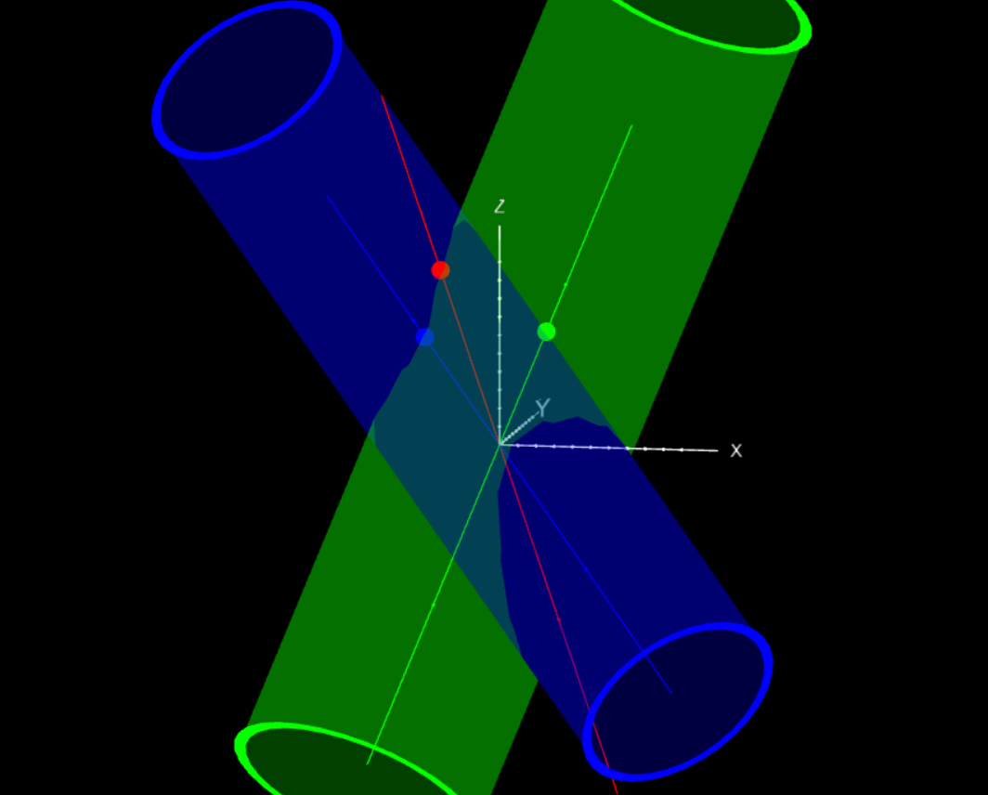
The product of quaternions. The image shows only the vector parts of the first quaternion (green), the second quaternion (blue), and the resulting quaternion (red). It is evident that the resulting quaternion lies on the surface of both cylinders. See details at https://www.youtube.com/watch?v=m92PeX1wDgI&list=PLdCIDX-rXAfTDQzhWGkgnF0K4zb0ySsBO&index=2&pp=gAQBiAQBsAQB

Rotation of a Vector Around an Axis

Let's now consider the expression

q⁻¹p

In the coordinate system q (where is directed along z), q looks similar to (6.16), but with the opposite sign:

q⁻¹ = (6.16)

Then the product q⁻¹p will be

q⁻¹p = |p₀₃| + jp₂ (6.18)

Thus, will rotate around in the opposite direction.

Now let's think about it: if in the expression

qp

q makes rotate around , and in the same expression p makes rotate around , then what will be the geometry of the expression

qpq⁻¹ (6.24)

I suggest taking a pause in reading and reflecting, then compare with my answer..

And my answer is as follows. Since quaternion multiplication is associative, we will consider (6.24) in any order. Let's first look at

pq⁻¹ (6.25)

Here q⁻¹ causes p to rotate in the (x, y) and (z, w) planes in one direction. Now let's consider

q(pq⁻¹) (6.26)

Here q causes (pq⁻¹) to rotate in the (z, w) plane in the opposite direction, and in the (x, y) plane in the same direction. Thus, ultimately, the construction

qpq⁻¹ (6.27)

leaves the scalar part of p unchanged, while the vector part rotates around the axis defined by , at an angle also defined by q. Graphically, it looks like the vector part of p rotates around the vector on the surface of a cylinder. However, if we view the vector as a segment with a ball at the end, then as the angle at q changes, this segment moves along the surface of a cone, while the ball itself moves along the cylinder.

Let's verify this algebraically through direct calculations, using (6.16) and (6.17):

qpq⁻¹ = (|p₀₃| + jp₂) = (|p₀₃| + jp₂)=|p₀₃| + jp₂ (6.28)

Let's compare this with the original p from (6.17):

p = |p₀₃| + jp₂ (6.29)

Precisely that is obtained: the operation qpq⁻¹ results in the rotation of the vector part around the axis , defined by the quaternion q itself. And if the real part of the quaternion p was initially zero, then in this case it turns out that the vector is transformed into a new vector by a rotation around the axis .

Now, with minimal effort, we have obtained our main result, facilitated by the trick of transitioning to the appropriate coordinate system. Previously, at this point, there was a standard proof, which was longer, more tiresome, and didn't provide a geometric picture. To complete the picture, let me say that without transitioning to a special coordinate system, one can consider (6.27) for a pure , take the conjugate of this expression, show that this conjugate is equal to the negative of the original, i.e., that

(6.30)

And this would mean that qpq⁻¹ is also a vector. Then it would be necessary to prove that the transition of the original vector to a new one can be achieved by some rotation. Of course, in this case, it would not be difficult to guess that in the general case of an arbitrary quaternion p, its scalar part would not change under the operation of (6.27).

In general, transitioning to the chosen coordinate system simplifies everything and, moreover, allows us to use ordinary three-dimensional geometric concepts and shapes (spheres and cylinders). This ultimately enables us to discuss quaternions using words, not formulas, which is extremely important. Now we can reason about rotations without complex calculations, using only words, and these words will be accurate.

Unit Quaternion Formula

Finally, I must mention the general formula of a unit quaternion, directed along a certain axis in three-dimensional space. Arnold in [4] claimed that this formula is hidden from physicists, so, taking the opportunity, I send them greetings and reveal the secret.

Look, since

q = q₀ + iq₁ + jq₂ + kq₃ (5.1)
|q|² = q₀² + q₁² + q₂² + q₃² (6.1)

and all components of q in absolute value are less than or equal to 1, then q₀² can be rewritten as , and then q₁² + q₂² + q₃² will be . Accordingly, q can then be expressed through the sum of scalar and vector parts:

q = + ₌ + () (6.31)

where is the unit vector of the quaternion's vector part. I invite you to think about this form of representation and how the unit vector can be derived from the basic definition of a quaternion (5.1).

7. Practical Example

Let's solve a problem: we need to rotate a point on the unit sphere with the directional vector (1, 2, 3) (this is p) around an axis with the directional vector (-1, 1, 1) by 70 degrees (this is q). The directional vectors here need to be normalized to and .

Let's find our quaternion p, which in this case is equal to the vector (with the angle equal to 90 degrees):

p = 0.27i + 0.53j + 0.80k

And q:

q = 0.34 + (-0.577i + 0.577j + 0.577k) * 0.94 = 0.34 – 0.54i + 0.54j + 0.54k
q⁻¹ = 0.34 + 0.54i - 0.54j - 0.54k

And let's first calculate

pq = -0.58 – 0.05i -0.4j +0.71k

Then

q⁻¹(pq) = -0.93i -0.179j + 0.312k

For simplicity, you can use any online quaternion calculator.

It is evident that the real part is indeed zero. I can't say that manually calculating such expressions is enjoyable, but, in any case, it is faster than recalculating the same thing in matrix form.

8. What's Next

There are several key points that I want to use for visualizing quaternions. They are not at all unique, but for some reason they are rarely combined:

- Choice of Special Coordinate Systems
- Working Only with Unit Quaternions
- Emphasis on using not so much four-dimensional, but 2+2 or 3+1 dimensional projections for representing quaternions. Sometimes attempts are made to engage visual insights and try to visually represent quaternions as objects of a four-dimensional world. I can only tip my hat to such people and their imagination. For the rest, lower-dimensional projections will suffice.
- A certain reciprocity of multiplication. That is, the product of two quaternions p * q can be understood simultaneously as the action of the quaternion p on the quaternion q from the left, and as the action of the quaternion q on the quaternion p from the right. Both actions lead to the same result. As a result, we get a symmetrical geometric interpretation in the form of rotating cylinders or planes.

Based on this list, I suggest a website where you can physically interact with quaternions: the program at https://vivkvv.github.io/QuaternionsGeometry/ and its source code at https://github.com/vivkvv/QuaternionsGeometry (it’s JavaScript + React application).

Explanations related to this website will also be useful:
https://www.youtube.com/watch?v=m92PeX1wDgI&list=PLdCIDX-rXAfTDQzhWGkgnF0K4zb0ySsBO&index=2&pp=gAQBiAQBsAQB

Literature

- Klein "Elementary Mathematics from an Advanced Standpoint," Vol. 1, pp. 88-111
- Polak L.S. "William Hamilton, 1805—1865" (Russian edition)
- Hamilton W.R. "Selected Works"
- Arnold V.I. "Geometry of Complex Numbers, Quaternions, and Spins" (Russian edition)
- Gelfand, Minlos, Shapiro "Representation of the Rotation Group and Lorentz Group, and Their Applications"
- Andrew J. Hanson “Visualizing Quaternions”

